Cauchy’s integral formula

$$\left[intro\right]$$

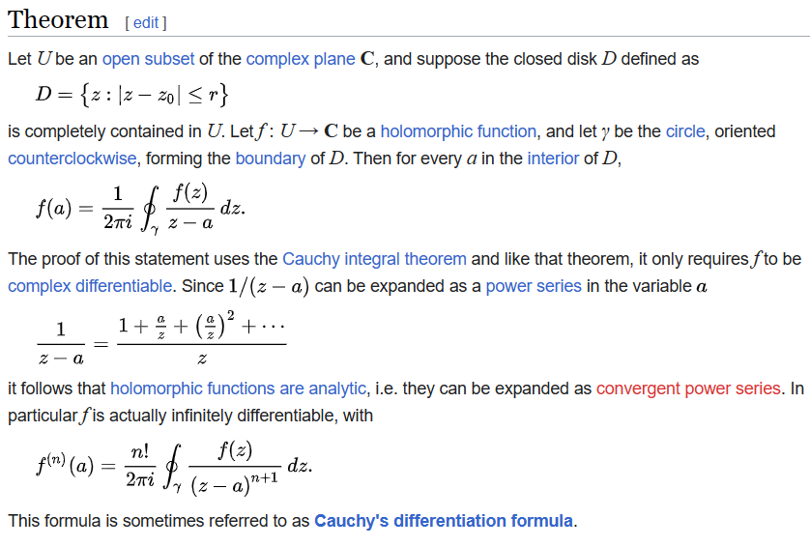

$$\left[figure\right]$$

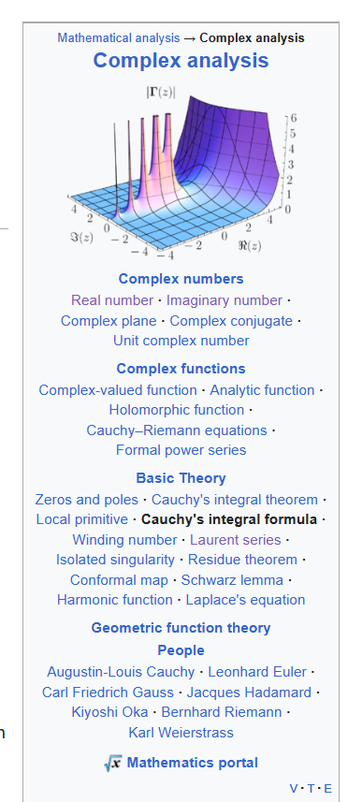

Ref:

[Cauchy's integral formula - Wikipedia](https://en.wikipedia.org/wiki/Cauchy%27s_integral_formula)